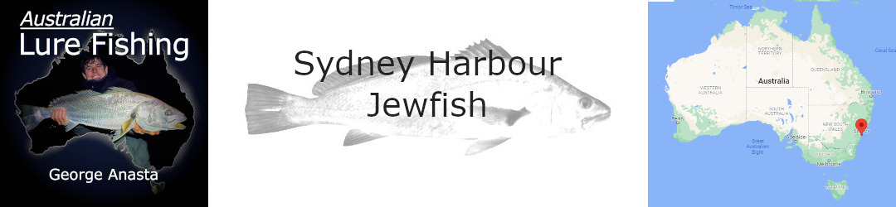
Australian Lure Fishing Podcast Episode 474
Go to the episode online | Download mp3

George Anasta
Sydney Fishing Personality And Land-Based Fishing Guide
George grew up fishing the waters of greater Sydney, where he's targeted all manner of species on lures. He's spent plenty of time chasing jewfish from land, kayak and boat, even doing so gigs as a land-based fishing guide from time to time. George has also had a long association with Daiwa and loves to use their tackle.

_____________________________________________________________

George’s Sydney Harbour Jewfish Tips
- It’s super important to keep the lure right in front of the fish, in the strike zone, ideally within one to one and a half metres from the bottom. If you’re using lure styles that are hopped up and down, be prepared for a subtle bite as the lure is falling.
- In late summer and through Autumn the water is still quite warm and the jewfish tend to be in the cooler, deeper areas at the seaward end of the harbour. As the season progresses and the water cools a little (below 22C), they’ll move further up the system.
- Finding jewfish in the Parramatta River and Sydney harbour involves looking for points, bends, places where there are eddies in current, especially if there is floating debris. Birds and especially pelicans are a great indicator.
- A sound is helpful for finding drop-offs (eg from 8-15 or 16m, but not necessarily steep), the edges of cockle beds, and baitfish close to the bottom (even if jewfish aren’t marking). There can be rocky outcrops in these areas too, so lure loss is to be expected at times.
- Often when jewfish are feeding they’ll be in the channel or on the flats and cockle beds. When they’re on the drop-offs and rocky structure they’re often not actively feeding and it can take a peppering of casts to activate them and get the strike.
- The last couple of hours of the runout tide, including the slack water and even the start of the run-in tide also, while the water is not running too fast. The bigger tides give smaller windows, but the fishing tends to run very hot for that short period.
- Overcast conditions and light rain tend to be optimum conditions for jewfish.
- Water clarity in Sydney Harbour can leave a bit to be desired at times, and it’s best to use darker coloured lures, or lures that have contrasting colours.
- George finds that putting some Lunker Hunter Squid or Sax Scent attractant on his lures when jew fishing.

George’s Sydney Harbour Jewfish Tackle
- The 2-4 kg, 7’ Daiwa Battler Thunderstorm rod, 2500 Daiwa Certate reel, PE1 braided line and 14lb leader is great for throwing smaller, lighter lures like paddle tail plastics or soft vibes.
- The 7’3”, 6-13kg Commander Garuda rod with a 3000 size Daiwa Morethan with PE2 mainline and 20lb leader is a good mid-range option.
- A 6’3” Daiwa HRF Baitcast rod with matching HRF baitcast reel, PE2 braid and 20lb fluorocarbon leader is the perfect combination for micro-jigging Sydney Harbour jewfish.

George’s Favourite Jewfish Lures
- 20g Jackall Transams and Zerek Fishtraps are George’s preferred soft vibes for Sydney’s Jewfish. Jewfish have the jaw pressure to destroy the trebles that come on these lures, so he upgrades the terminals to two size #2 Gamakatsu single inline hooks facing opposite directions on the tail and one size #1 Gamakatsu single inline hook on the belly. Soft vibes are great over flatter, sandy bottom around cockle beds. They’ll catch fish over other structure but are very snag prone. Cast upcurrent and allow the lure to sink to the bottom then lift it 1-1.5m off the bottom with an upward sweep of the rod, winding a little line at the top of the lift. Allow it to sink back down, keeping in touch with the lure and striking at the slightest twitch or unnatural movement of the line. Vary the size and aggressiveness of the rod lifts until you find what’s working.
- Soft plastic paddle tails in the 4-5” size range with 3/8 oz TT HeadlockZ jig heads are a great option when retrieved in similar ways to the vibe and can be worked around rockier areas and drop-offs with less chance of getting snagged. Mixing it up with some lifts and long slow rolls or trying some short, sharp hops from time to time also work, being careful to keep the lure within 1.5m of the bottom. Bigger paddletails of around 6” are good when bigger fish are expected and tend to work best on the long-roll technique.
- Palms Slow Blatt Oval Microjigs from 20-40g are great around wrecks and the edges of reefs. 40g is great in water depths of 20 or more metres and even a 60g jig can be effective at times. These lures are best fished vertically, but can also be cast and long lifted back. Simply working them up and down with rod lifts is effective. Upgrading the assist hooks and adding some small plastic squid skirts to the hooks can be effective, as well as willow blades on the bottom of the lure. Small Maria Shore Tricker jigs are also effective when the fish are feeding on smaller bait.
- All of the lures mentioned should be dead-sticked beneath the boat for a while before being wound in for the next cast.

